# Importing a new catalogue

**STEP 1**. When logged in as an administrator of the web site, select ‘Dashboard’ from the black bar at the top of the screen. Then select the ‘All Import’ menu option.

**STEP 2**. A screen is presented with 3 large button options, ‘Upload a file’, ‘Download from URL’ and ‘Use Existing File’.

**STEP 3**. Click on the ‘Upload a file button’. A screen is popped showing a file browser.

**STEP 4**. Select the catalog CSV file to upload and click the ‘Open’ button. See image below.

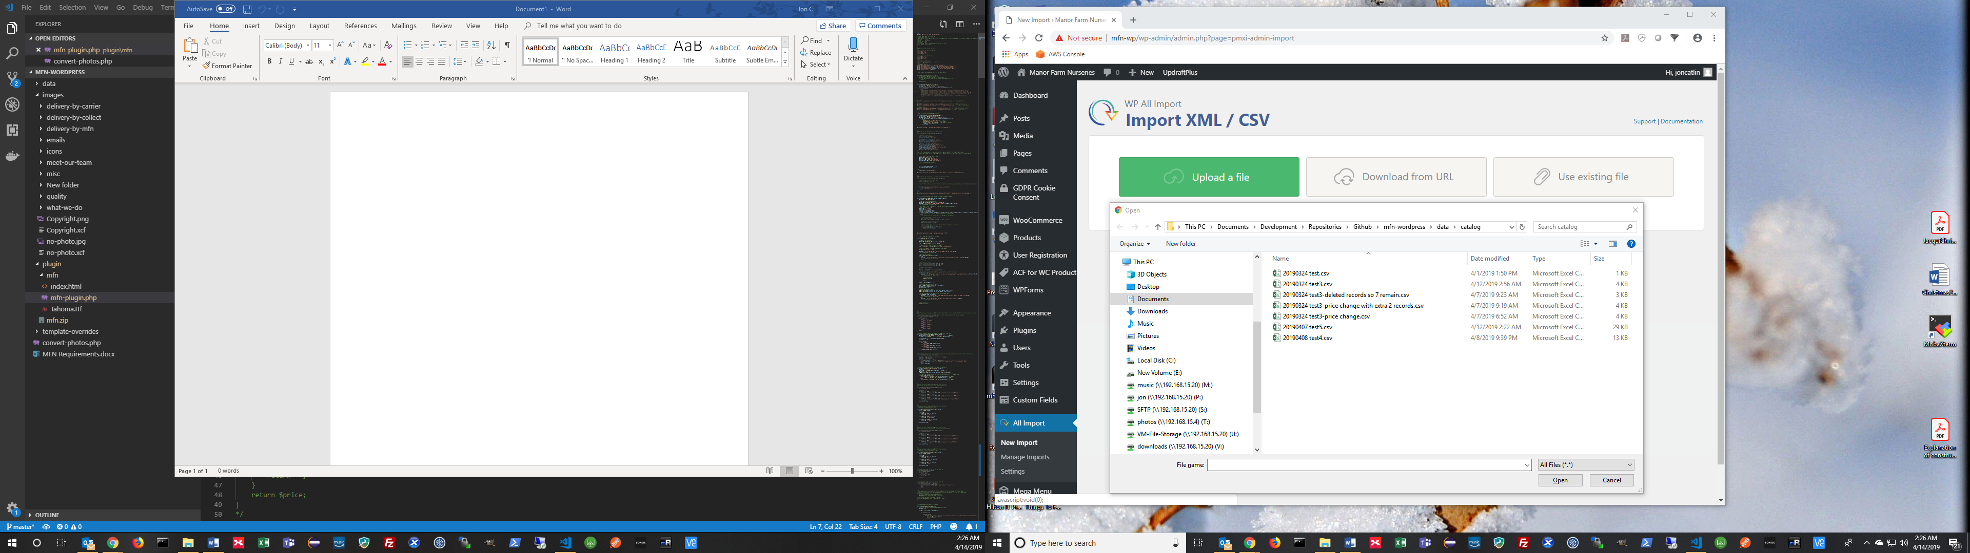

**STEP 5**. The file is uploaded and the screen show ‘Upload complete’ and the ‘New Items button is selected’.

**STEP 6**. Click on the ‘Existing Items’ button.

**STEP 7**. Select ‘Woo Commerce Products’ from the drop down labelled ‘Import to existing’

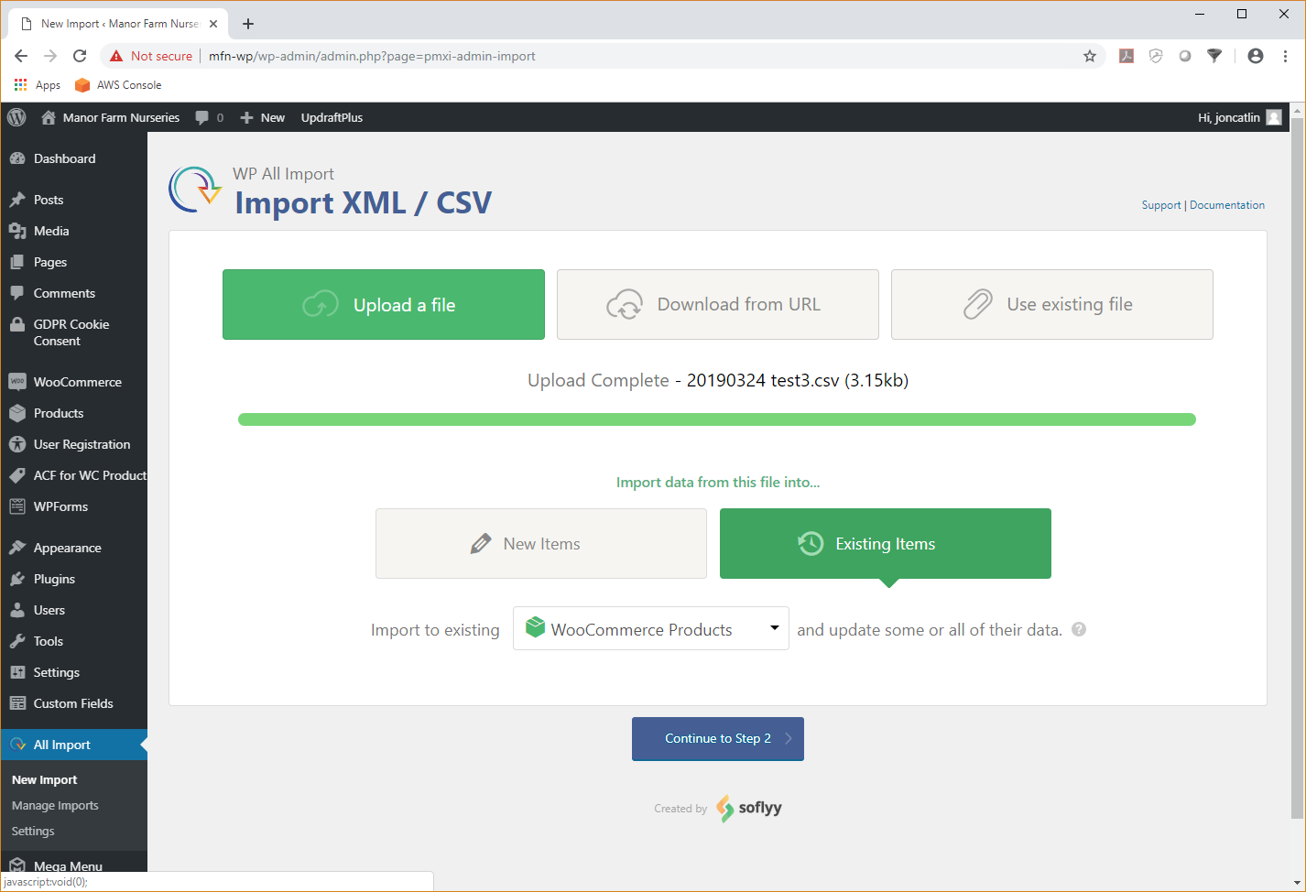

**STEP 8**. Click on the blue button labelled ‘Continue to Step 2’.

**STEP 8**. A screen is displayed like the one in the image below.

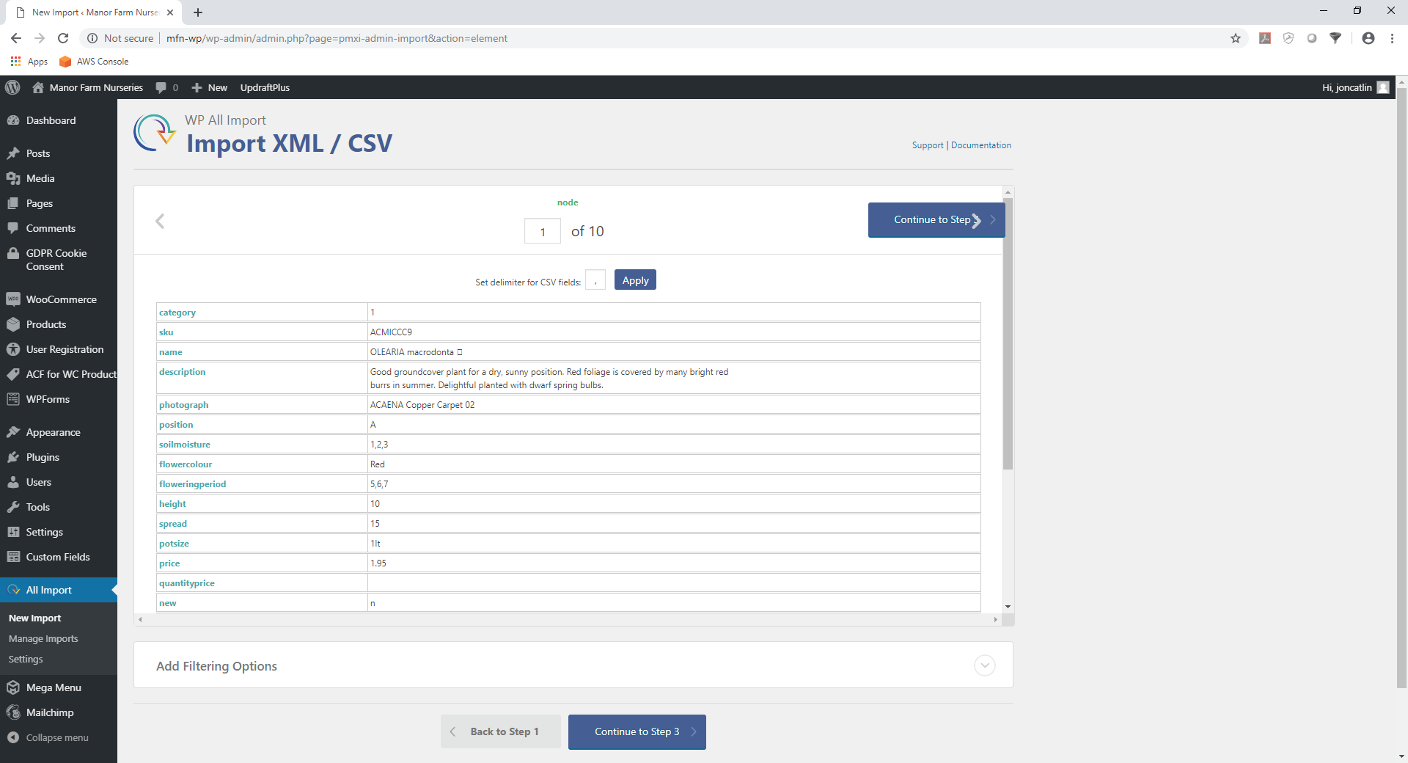

**STEP 8**. Do not change anything, just click on the blue button at the bottom of the screen labelled ‘Continue to Step 3’.

**STEP 9**. Wait for the screen to display and scroll to the bottom of the screen.

**STEP 10**. Click on the ‘Load Template…’ drop down at the bottom of the screen and select mfn. See image below.

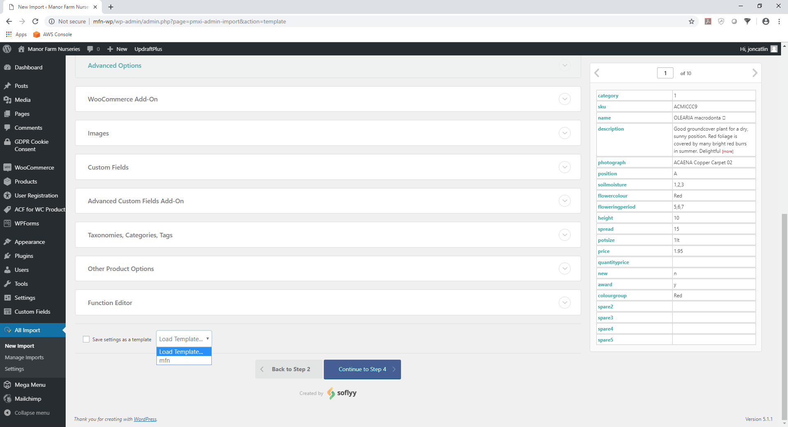

**STEP 11**. The screen will refresh and show the fields filled in with information. See image below.

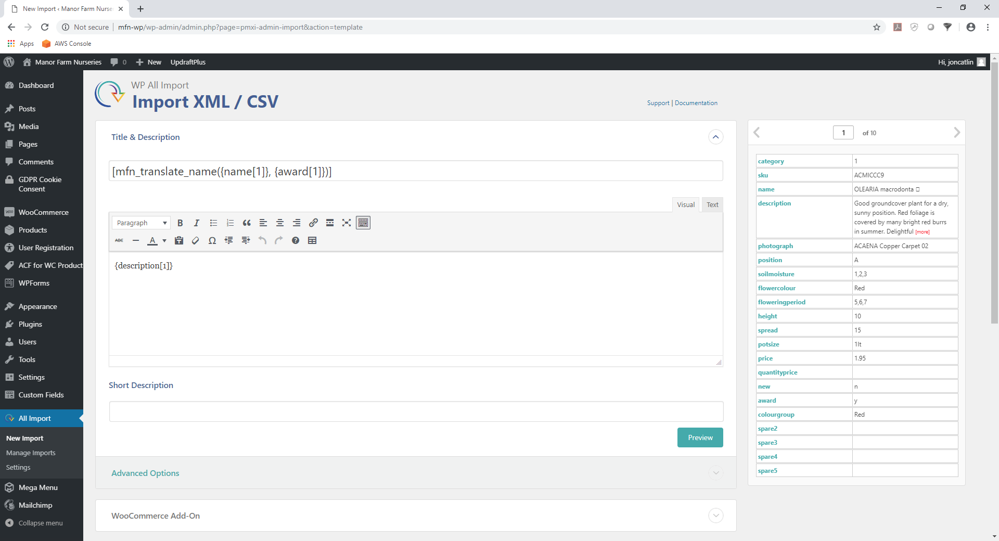

**STEP 12**. Scroll to the bottom of the screen again and select the blue button labelled ‘Continue to Step 4’.

**STEP 13**. Once the next screen has been displayed, scroll to the bottom and click on the blue button labelled ‘Continue’.

**STEP 14**. A screen is displayed like the one shown in the image below.

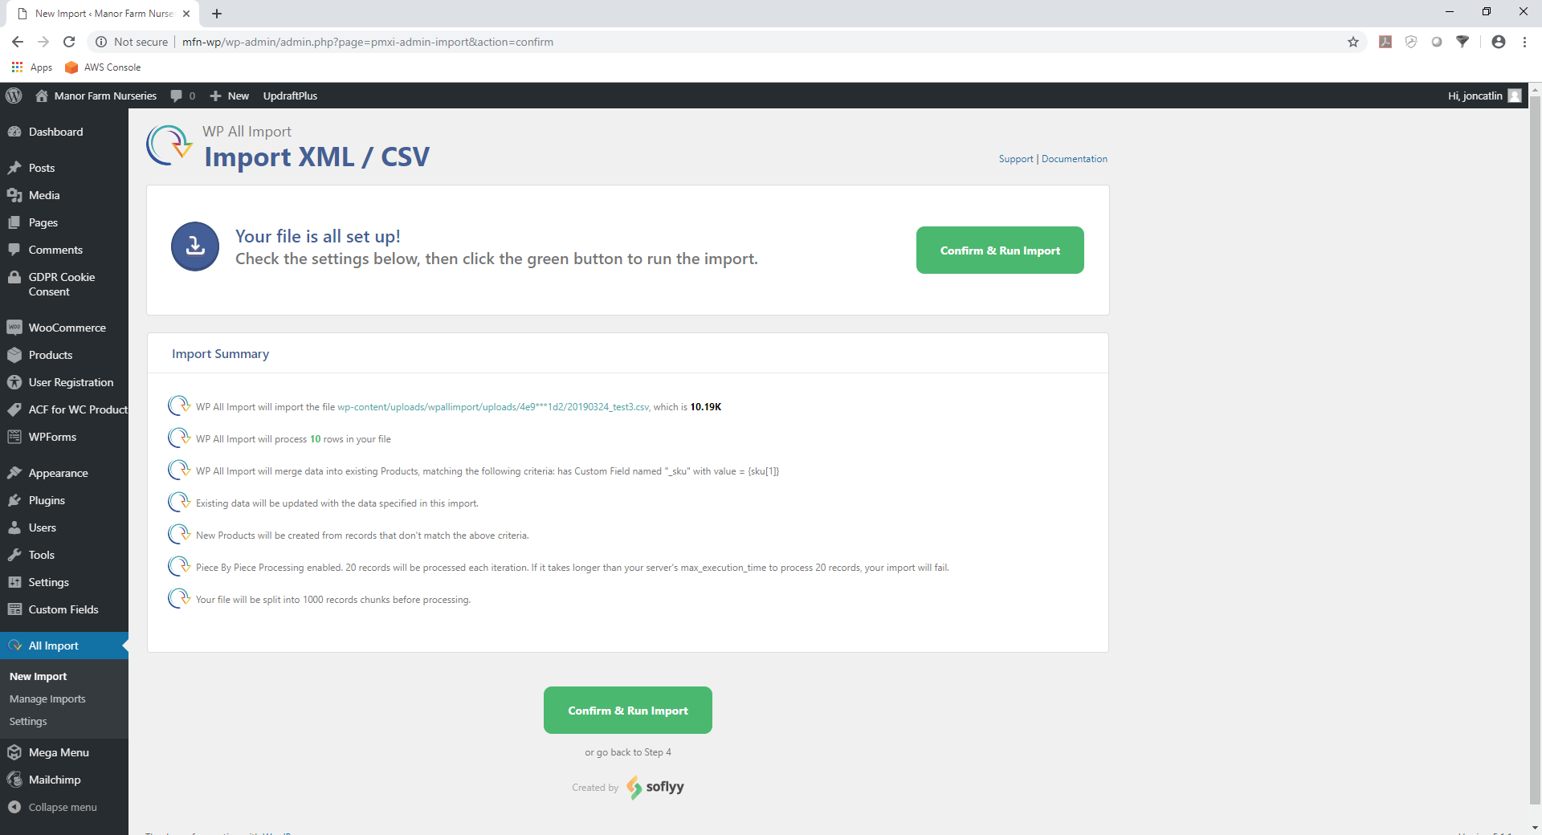

**STEP 15**. Click on the green button labelled ‘Confirm & Run Import’.

**STEP 16**. After a long time, could be an hour or so, the screen will look like the image below, showing that the import is complete. During the import process the screen will update several times showing the progress.